SECTION-2 - (CSS assignments) Steps to follow:

1. Create a new branch ‘css-assignments’.
2. Switch to ‘css-assignments’ branch.

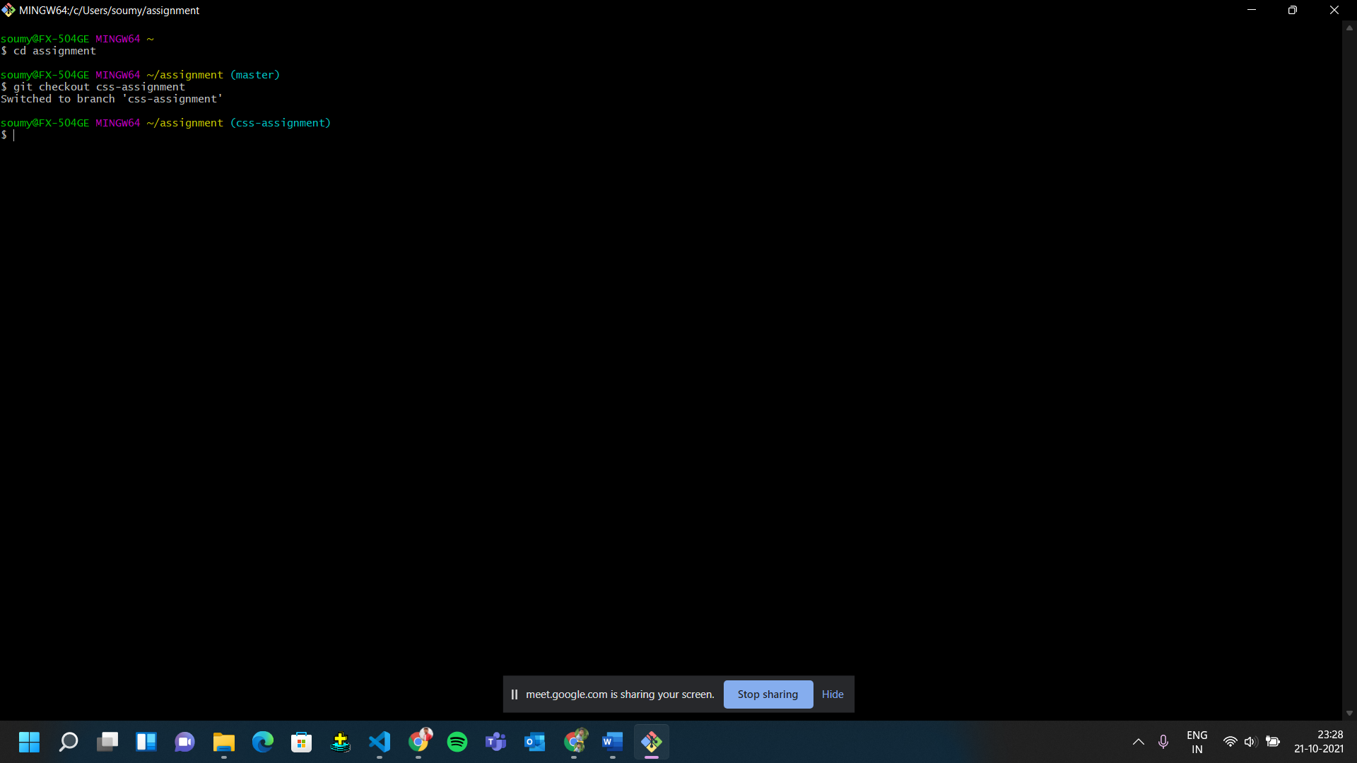

1. Copy all CSS assignments inside ‘Assignments’ folder.
2. Commit CSS assignments into ‘css-assignments’ branch.

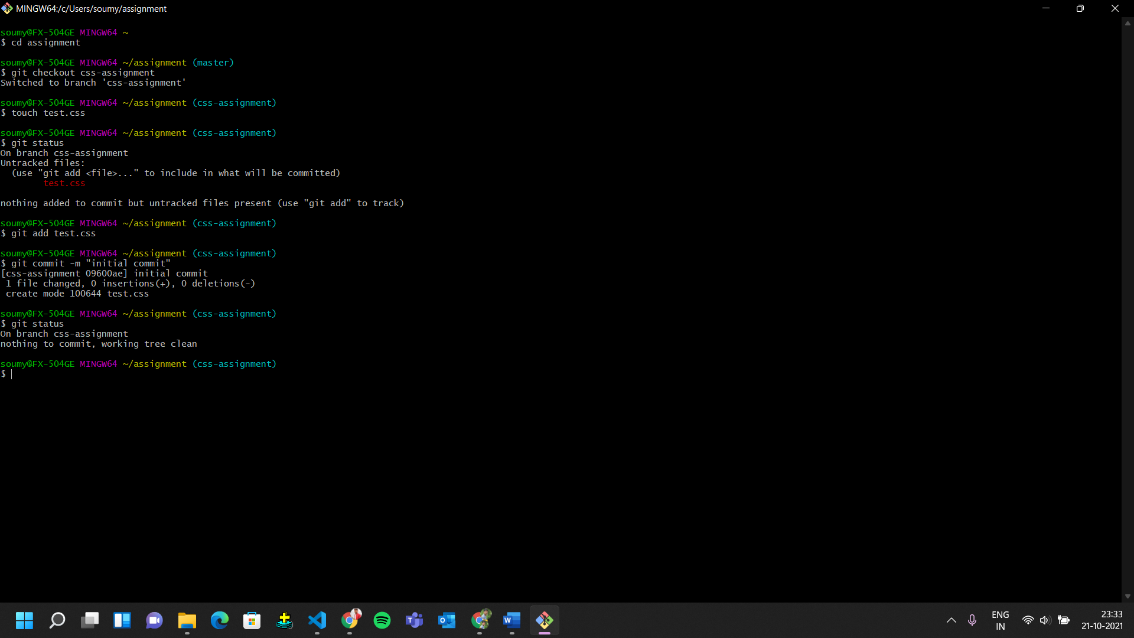

1. Make minor changes into README.txt file on line 1 belonging to ‘css-assignments’ branch.

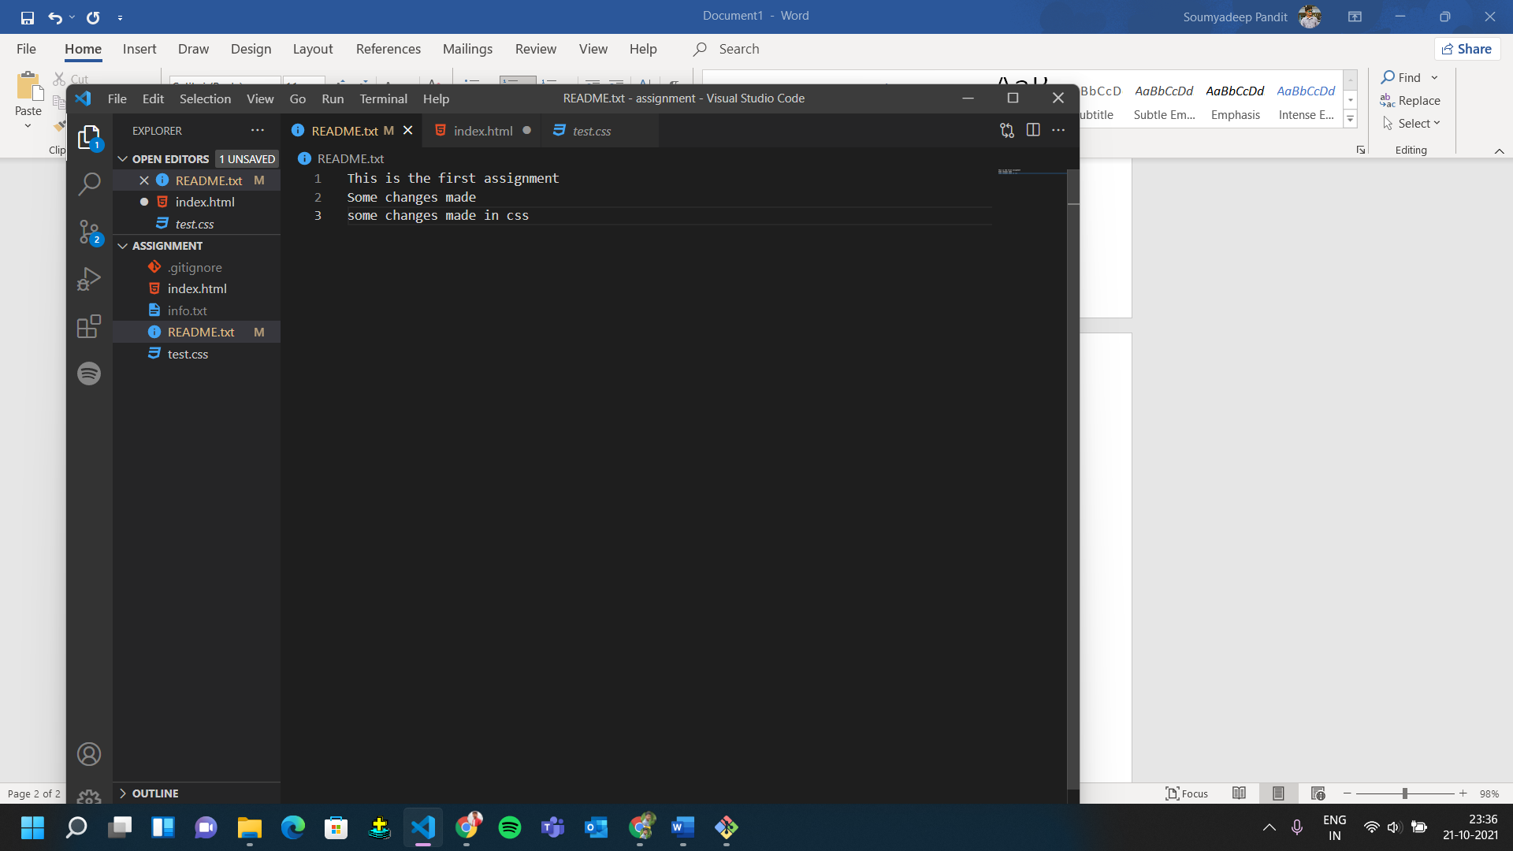

1. 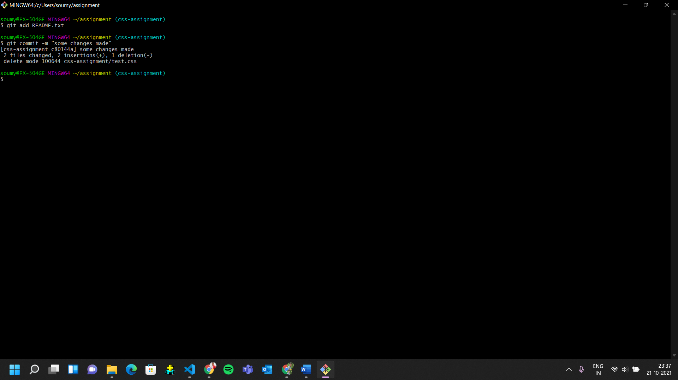Commit those changed files.
2. 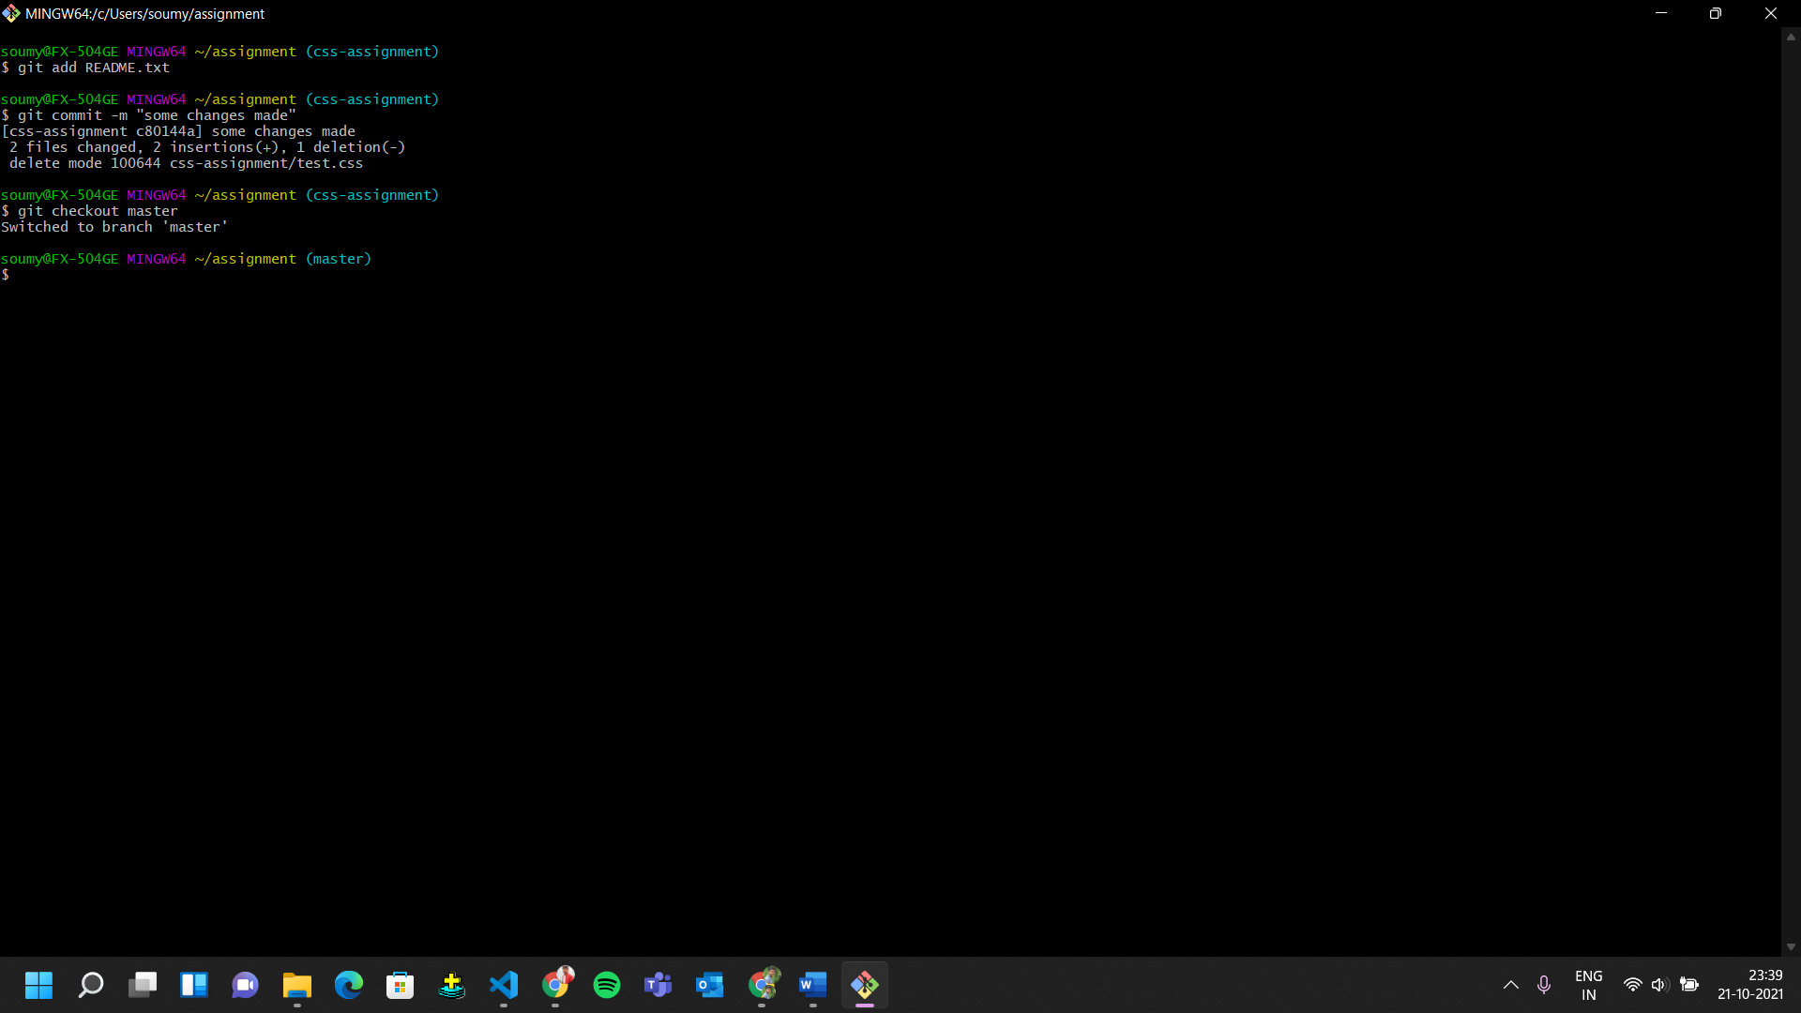Switch to master branch.
3. 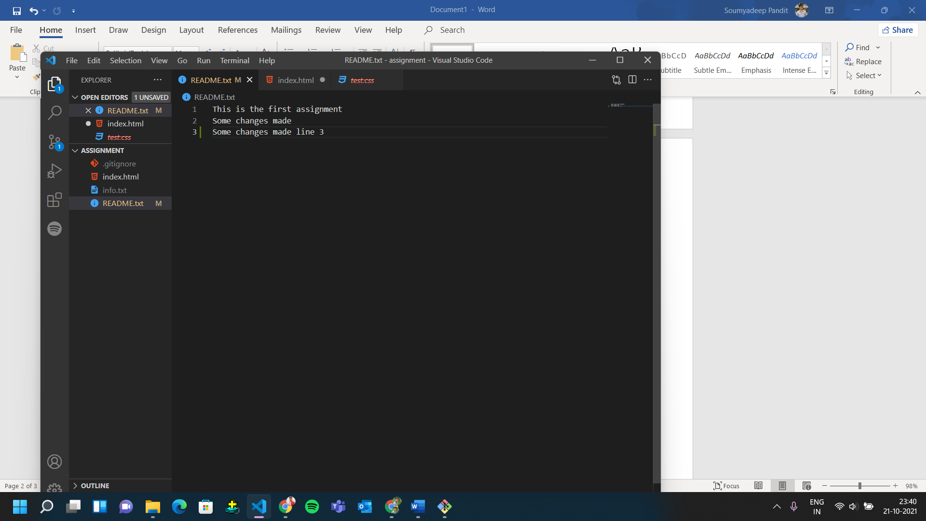Make minor changes into README.txt file on line 3 & commit those changes into master.

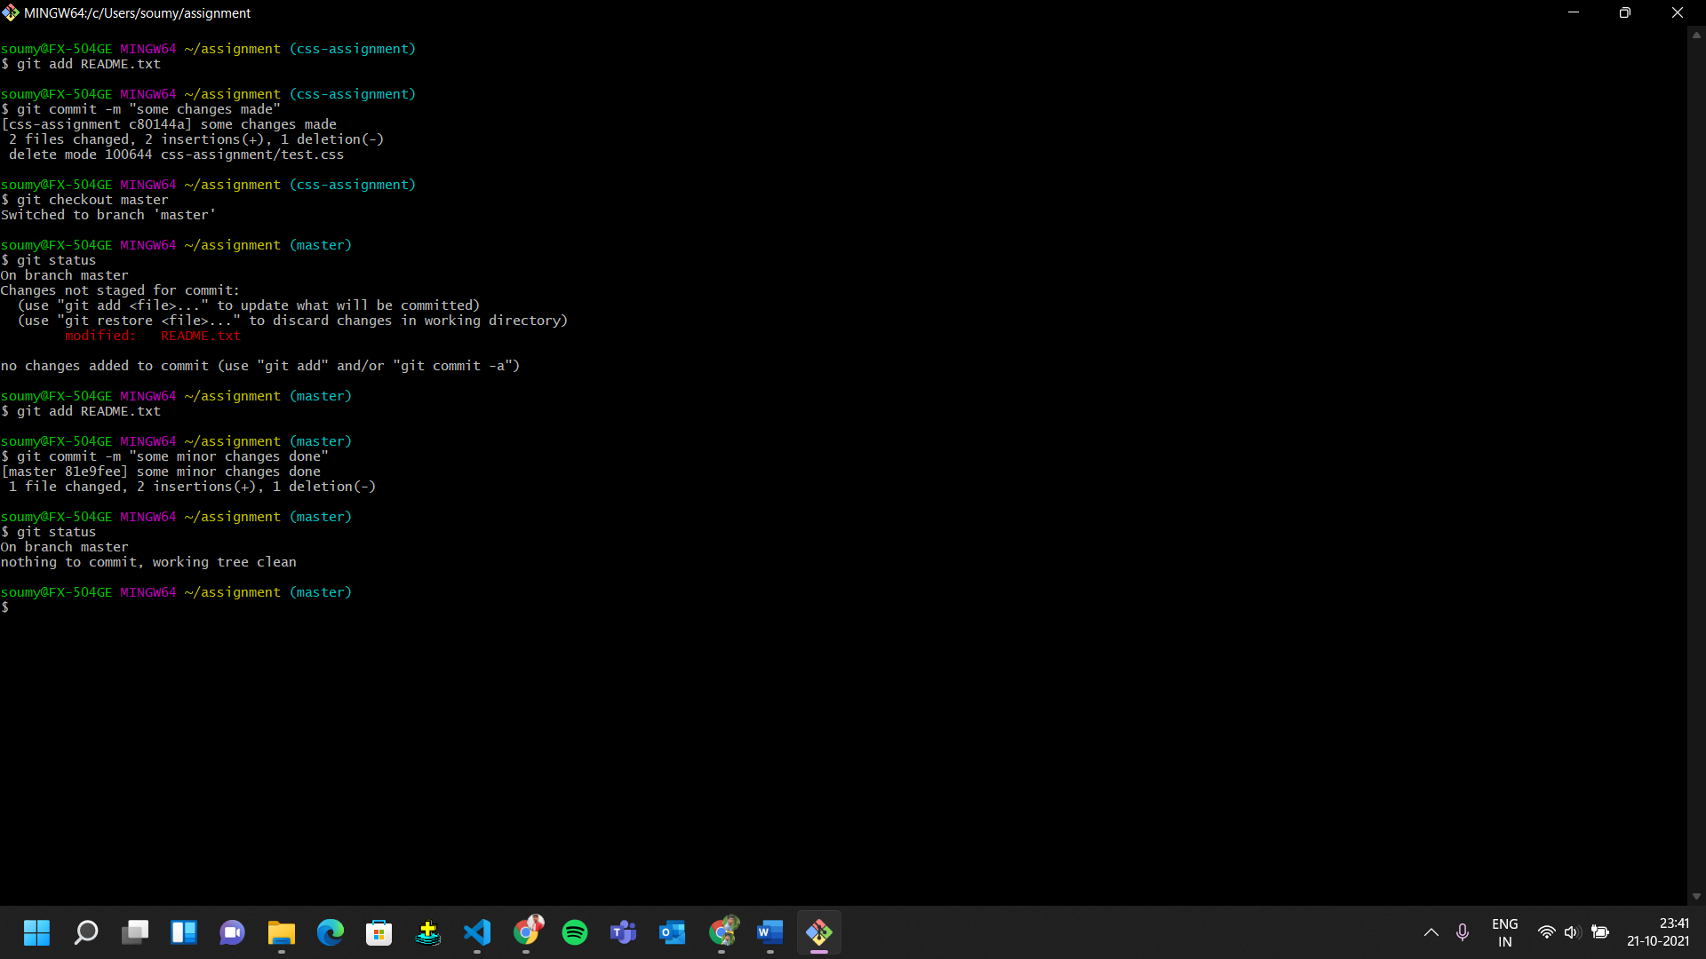

1. 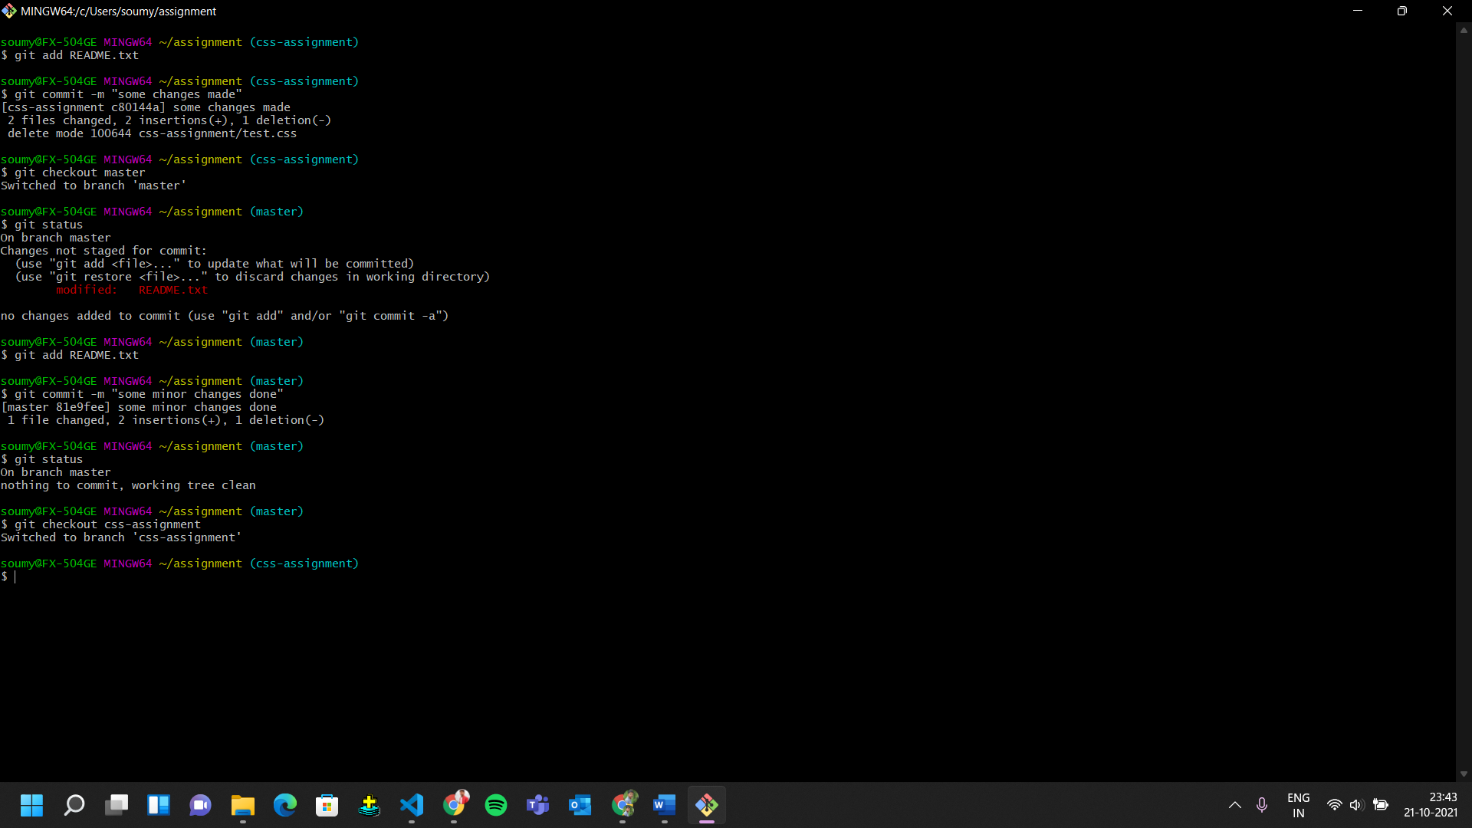Again switch to ‘css-assignments’ branch.
2. Make minor changes into few files belonging to ‘css-assignments’ branch.
3. Commit those changes.
4. Switch to master.
5. Merge ‘css-assignments’ branch into master. Confirm all css assignments are shown in master.
6. Finally delete the ‘css-assignments’ branch.

